1. Java Priority Queue :
#CODE:
import java.util.*;

class Student {
private int id;
private String name;
private double cgpa;

public Student(int id, String name, double cgpa) {
this.id = id;
this.name = name;
this.cgpa = cgpa;
}

public int getID() {
return id;
}

public String getName() {
return name;
}

public double getCGPA() {
return cgpa;
}
}

class Priorities {

public List<Student> getStudents(List<String> events) {

PriorityQueue<Student> pq = new PriorityQueue<>(
(a, b) -> {

// Higher CGPA first
if (a.getCGPA() != b.getCGPA()) {
return Double.compare(b.getCGPA(), a.getCGPA());
}

// Alphabetical name
if (!a.getName().equals(b.getName())) {
return a.getName().compareTo(b.getName());
}

// Smaller ID first
return Integer.compare(a.getID(), b.getID());
}
);

for (String event : events) {

String[] parts = event.split(" ");

if (parts[0].equals("ENTER")) {

String name = parts[1];
double cgpa = Double.parseDouble(parts[2]);
int id = Integer.parseInt(parts[3]);

pq.add(new Student(id, name, cgpa));

} else if (parts[0].equals("SERVED")) {

if (!pq.isEmpty()) {
pq.poll();
}
}
}

List<Student> result = new ArrayList<>();

while (!pq.isEmpty()) {
result.add(pq.poll());
}

return result;
}
}

public class Solution {

public static void main(String[] args) {

Scanner sc = new Scanner(System.in);

int n = Integer.parseInt(sc.nextLine());

List<String> events = new ArrayList<>();

for (int i = 0; i < n; i++) {
events.add(sc.nextLine());
}

Priorities priorities = new Priorities();

List<Student> students = priorities.getStudents(events);

if (students.isEmpty()) {
System.out.println("EMPTY");
} else {
for (Student student : students) {
System.out.println(student.getName());
}
}

sc.close();
}
}

OUTPUT:
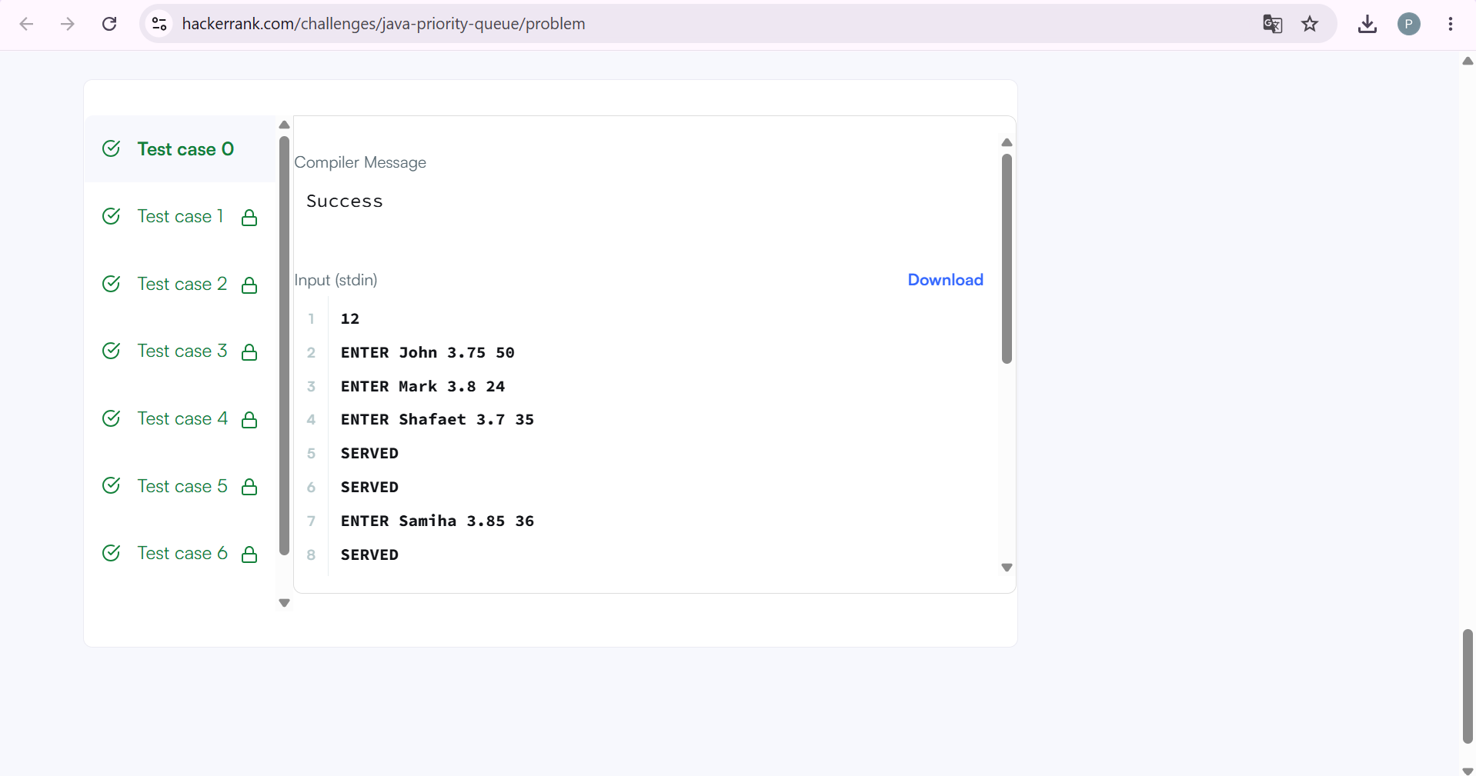

2. Java Arraylist :
#CODE:
import java.util.*;

public class Solution {
public static void main(String[] args) {

Scanner sc = new Scanner(System.in);

int n = sc.nextInt();

ArrayList<ArrayList<Integer>> list = new ArrayList<>();

// Read the lines
for (int i = 0; i < n; i++) {

int d = sc.nextInt();

ArrayList<Integer> row = new ArrayList<>();

for (int j = 0; j < d; j++) {
row.add(sc.nextInt());
}

list.add(row);
}

// Number of queries
int q = sc.nextInt();

for (int i = 0; i < q; i++) {

int x = sc.nextInt();
int y = sc.nextInt();

// x and y are 1-based
if (x <= list.size() && y <= list.get(x - 1).size()) {
System.out.println(list.get(x - 1).get(y - 1));
} else {
System.out.println("ERROR!");
}
}

sc.close();
}
}

OUTPUT:
